Software Architecture Document (SAD) — Version 1.0

Smart IT Service Request and Support Ticket System

(WSiT – World Systems for Information Technology)

Team members:
Abdulaziz 2309116441
Hamdi alnaqeeb 2309116178
Fares stouhi 2309115179
Team contributions:
Abdulaziz: Backend REST API implementation, DB connection, and Logical View design.
Hamdi alnaqeeb: Frontend UI deployment: Client-side HTTP requests and Process View the design for workflows.
Fares stouhi: System selection definition Use Case View documents and common architectural style.

Document Property | Value
Version | 1.0 (Phase 1 / MVP)
Date | 2026-05-05
Status | Draft — Under Review
Architecture Style | Layered REST API Architecture
Document Format | 4+1 Architectural Model (Kruchten, 1995)

1. Introduction

1.1 Purpose

It is a Software Architecture Document (SAD) covering the entire architectural design of the Smart IT Service Request and Support Ticket System to WSiT (World Systems for Information Technology). It is the main technical guide to be used by the development team, academic reviewers as well as future users of the system.

1.2 Scope

The system discussed in this document covers Phase 1 (MVP) of the system, which includes: - Customer self-service ticket submission - Role-based access: to customers and administrators - Technician assignment and ticket status management - RESTful API backend based on FastAPI and SQLite - React-based single-page web application frontend

1.3 Target System

The system is implemented as a web application that can be accessed using any contemporary browser. The backend provides a JSON/HTTP REST API, which will only be used by the React frontend in Phase 1.

1.4 Architecture Style: Layered REST API
The system implements a four-layer architecture separating concerns across:
Layer | Responsibility
Presentation | React SPA — renders UI, manages local state, calls API
Controller (API) | FastAPI route handlers — validates requests, delegates to services
Business Logic | Service modules — enforces rules, orchestrates data operations
Data Access | SQLAlchemy ORM — abstracts SQLite queries behind repository functions
Communication between the frontend and backend is exclusively over HTTP/JSON (REST) using well-defined Pydantic schemas as contracts.

2. System Selection

2.1 System Name
Smart IT Service Request and Support Ticket System

2.2 Description
WSiT provides managed technology services across multiple verticals. Customers currently report issues via email and phone, resulting in untracked requests, missed SLAs, and poor visibility. This system replaces the informal process with a structured, digital ticketing workflow accessible 24/7.

2.3 System Users
Actor | Description
Customer | An individual or organizational client who submits service requests and tracks ticket status
Administrator | A WSiT staff member who manages incoming tickets, assigns technicians, and updates ticket lifecycle

2.4 Main Service Functionalities (Service Types)
Service | Description
CCTV | Installation, maintenance, and troubleshooting of surveillance systems
Networking | LAN/WAN configuration, Wi-Fi setup, connectivity issues
Maintenance | General hardware and physical IT asset repair
Smart Home | IoT device installation and integration
Access Control | Biometric and card-based entry system support
Tech Support | General software, OS, and device troubleshooting

3. 4+1 Architectural Model

3.1 Use Case View

3.1.1 Actors
- Customer — submits requests, tracks tickets
- Administrator — manages the full ticket lifecycle

3.1.2 Use Cases
ID | Use Case | Actor | Description
UC-01 | Register Account | Customer | Create a new customer account
UC-02 | Login | Customer / Admin | Authenticate and receive session token
UC-03 | Submit Service Request | Customer | Create a new support ticket with service details
UC-04 | View My Tickets | Customer | List own submitted tickets with status
UC-05 | View Ticket Details | Customer / Admin | View full information on a single ticket
UC-06 | View All Tickets | Admin | See all tickets across all customers
UC-07 | Assign Technician | Admin | Assign a named technician to an open ticket
UC-08 | Update Ticket Status | Admin | Change ticket status (open → in_progress → resolved → closed)

3.1.3 Use Case Diagram
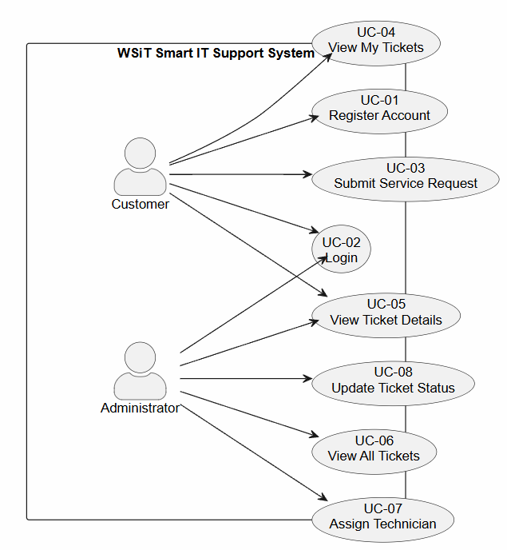

3.2 Logical View

3.2.1 Layer Breakdown
Presentation Layer (React SPA) - LoginPage.jsx — handles authentication and registration UI - CustomerDashboard.jsx — ticket submission form and personal ticket list - AdminDashboard.jsx — full ticket management with inline assign/status controls - TicketDetails.jsx — read-only detail view for a single ticket - Navbar.jsx, StatusBadge.jsx — reusable components - api/client.js — centralised Axios instance with token injection
Controller Layer (FastAPI Routes) - routes/auth.py — POST /auth/login, POST /customers/register - routes/tickets.py — all ticket CRUD and management endpoints
Business Logic Layer (Services) - services/auth_service.py — password hashing, token generation, admin seeding - services/ticket_service.py — ticket creation, retrieval, status/assignment updates
Data Access Layer (SQLAlchemy) - models/models.py — User and Ticket ORM entities - schemas/schemas.py — Pydantic request/response contracts - database/database.py — engine, session factory, get_db dependency

3.2.2 Component Diagram
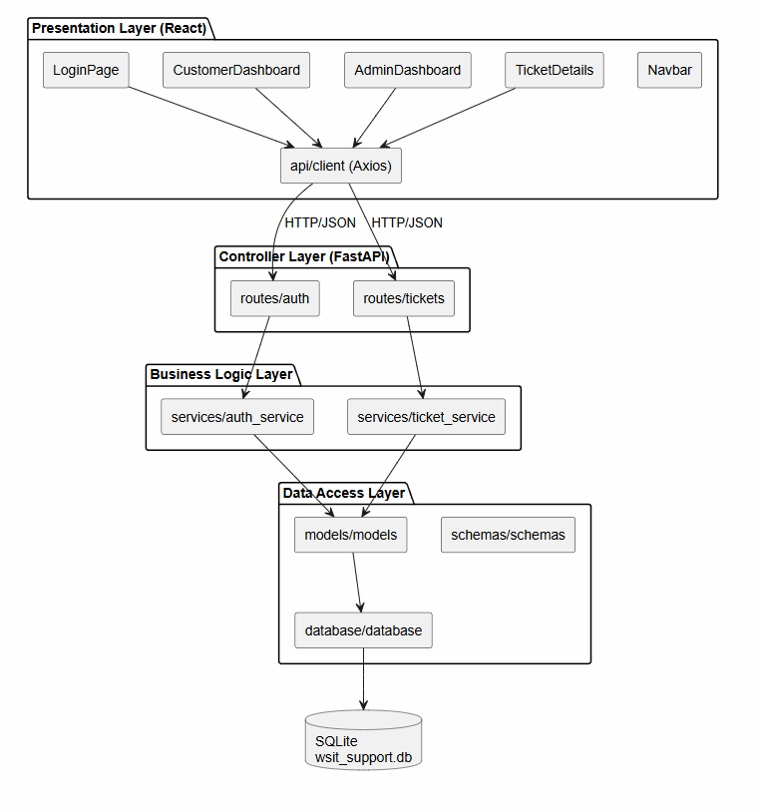

3.3 Process View

3.3.1 Key Workflows
Ticket Submission Flow: 1. Customer fills out the service request form on CustomerDashboard 2. Axios POSTs to POST /tickets with Authorization: Bearer <token> 3. Route handler decodes token, retrieves user from DB 4. ticket_service.create_ticket() writes a new Ticket row (status = open) 5. Response returned and ticket appears in customer’s ticket list
Admin Ticket Management Flow: 1. Admin logs in and lands on AdminDashboard 2. GET /tickets returns all tickets (admin-only) 3. Admin enters technician name and clicks Assign → PUT /tickets/{id}/assign 4. ticket_service.assign_ticket() sets assigned_technician and status = in_progress 5. Admin selects new status from dropdown and clicks Save → PUT /tickets/{id}/status

3.3.2 Sequence Diagram — Customer Submits a Ticket

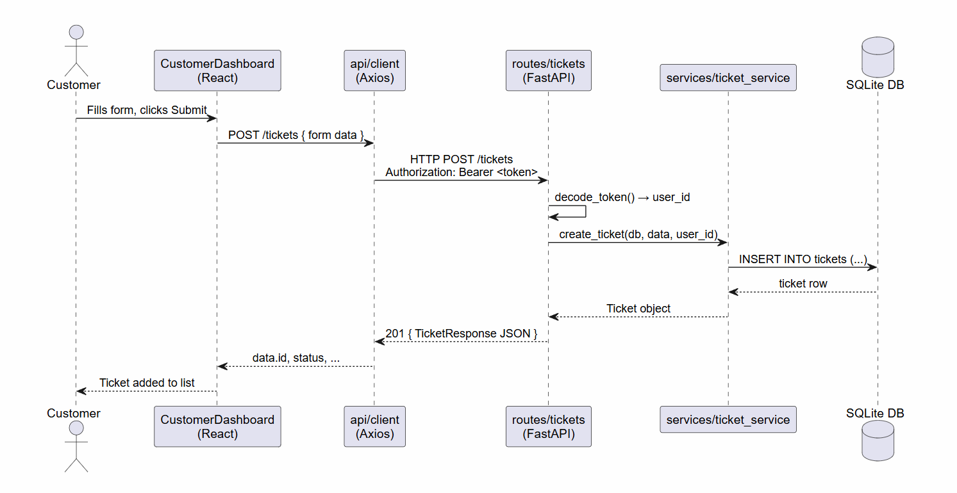

3.3.3 Activity Diagram — Admin Ticket Management

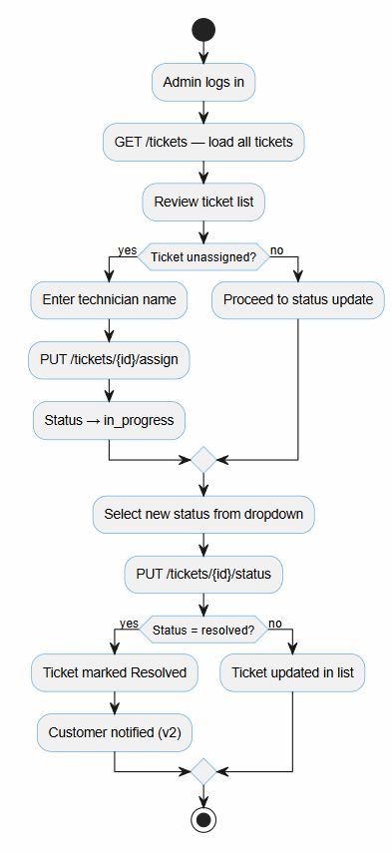

3.4 Development View

3.4.1 Module Organisation
smart-it-support-system/
├── backend/
│ ├── main.py # FastAPI app entry point, middleware, lifespan
│ ├── requirements.txt
│ └── app/
│ ├── database/
│ │ └── database.py # SQLAlchemy engine, SessionLocal, Base, get_db
│ ├── models/
│ │ └── models.py # User, Ticket ORM models + Enum definitions
│ ├── schemas/
│ │ └── schemas.py # Pydantic request/response schemas
│ ├── routes/
│ │ ├── auth.py # /auth/login, /customers/register
│ │ └── tickets.py # All ticket endpoints + token decode helpers
│ └── services/
│ ├── auth_service.py # Password hashing, mock token, admin seed
│ └── ticket_service.py # Ticket CRUD business logic
│
├── frontend/
│ ├── index.html
│ ├── package.json
│ ├── vite.config.js
│ └── src/
│ ├── main.jsx # ReactDOM mount point
│ ├── App.jsx # React Router, route guards
│ ├── index.css # Global styles
│ ├── api/
│ │ └── client.js # Axios instance with Bearer token interceptor
│ ├── components/
│ │ ├── Navbar.jsx # Top navigation bar with logout
│ │ └── StatusBadge.jsx # Coloured badge for status/priority
│ └── pages/
│ ├── LoginPage.jsx # Login + Register tabs
│ ├── CustomerDashboard.jsx
│ ├── AdminDashboard.jsx
│ └── TicketDetails.jsx
│
└── docs/
└── SAD_V1.md # This document

3.4.2 Dependency Summary
Layer | Technology | Version
Frontend Framework | React | 18.3
Frontend Build | Vite | 5.2
HTTP Client | Axios | 1.7
Frontend Routing | React Router | 6.23
Backend Framework | FastAPI | 0.111
ASGI Server | Uvicorn | 0.29
ORM | SQLAlchemy | 2.0
Validation | Pydantic | 2.7
Database | SQLite | (bundled)

3.5 Physical View

3.5.1 Phase 1 Deployment (Local / Development)
All services run on a single developer machine. The browser communicates with the Vite dev server (port 5173) which serves the React SPA. All API calls are directed to the FastAPI/Uvicorn process on port 8000. FastAPI reads and writes to a SQLite file (wsit_support.db) on the local filesystem.

3.5.2 Deployment Diagram
@startuml
skinparam backgroundColor #FAFAFA
skinparam nodeStyle rectangle
node "Developer Workstation" {
node "Browser\n(Chrome / Firefox)" as Browser
node "Vite Dev Server\n:5173" as Vite {
artifact "React SPA\n(static JS/HTML/CSS)" as ReactApp
}
node "Uvicorn ASGI Server\n:8000" as Uvicorn {
artifact "FastAPI Application\n(routes, services, models)" as FastAPI
}
database "SQLite File\nwsit_support.db" as SQLite
}
Browser --> Vite : HTTP GET /\n(serves index.html + JS bundles)
Browser --> Uvicorn : HTTP/JSON REST calls\n(CORS allowed from :5173)
FastAPI --> SQLite : SQLAlchemy ORM queries\n(read / write)
@enduml

3.6 Scenarios (+1 View)
The following scenarios trace end-to-end system behaviour through the architectural layers.

Scenario 1 — Customer Submits a CCTV Service Request
- Customer opens http://localhost:5173, lands on LoginPage.
- Enters credentials → POST /auth/login → receives mock token + role = customer.
- Token stored in localStorage; React Router navigates to /dashboard.
- Customer clicks + New Request, selects CCTV, fills form, submits.
- POST /tickets hits FastAPI → token decoded → ticket_service.create_ticket() → INSERT into SQLite.
- New ticket appears in the My Service Requests table with status open.

Scenario 2 — Admin Assigns a Technician
- Admin logs in with admin@wsit.com / admin123 → role = admin → navigated to /admin.
- GET /tickets retrieves all tickets; table renders with ticket #1 status = open.
- Admin types "John Doe" into the technician field for ticket #1 and clicks Assign.
- PUT /tickets/1/assign → ticket_service.assign_ticket() → assigned_technician = "John Doe", status = "in_progress".
- Table refreshes; ticket #1 now shows in_progress with technician John Doe.

Scenario 3 — Customer Tracks Ticket Status
- Customer logs in and opens /dashboard.
- GET /tickets/my returns own tickets including ticket #1.
- Customer sees status changed from open to in_progress, assigned technician visible.
- Customer clicks View → navigates to /tickets/1 → TicketDetails page shows all metadata.

4. Phase 1 Implementation Notes

4.1 Planned Version and Enhancements
Enhancement | Rationale
JWT-based authentication (replace mock token) | Security hardening for production
Password hashing with bcrypt | Replaces SHA-256 prototype hash
Email notifications on ticket updates | Improves customer communication
SLA tracking and escalation rules | Business priority management
File/image attachments on tickets | Richer problem reporting
Reporting dashboard with charts | Management visibility
Pagination and search on ticket lists | Performance at scale
Containerization (Docker Compose) | Reproducible deployment
Role expansion: Technician role | More granular access control

5. Conclusion
The Smart IT Service Request and Support Ticket System of WSiT offers a clean extensible underpinning of digiti sing IT service operations. The system provides good separation of concerns, easy testability and well-understood contract between the frontend and the backend, by using a Layered REST API Architecture and documenting it through the 4+1 Architectural Model.
Phase 1 provides a working MVP with the entire ticket lifecycle - customer submission through admin assignment to resolution - on a local development stack. The architecture is specifically conservative: SQLite and a mock token scheme ensure the barrier to entry is low and the codebase construct means the upgrading to postgre SQL, JWT auth and a cloud deployment is a matter of configuration rather than re-architecture.
The 4+1 views taken together show how the system addresses its stakeholder concerns: the Use Case View is used to validate functional completeness, the Logical View is used to ensure maintainability, the Process View is used to capture runtime behavior, the Development View is used to guide implementation, and the Physical View reflects the deployment reality. They form an impressive architectural foundation where Version 2 improvements can be planned and implemented with assurance.

